CERTIFICATE OF PARTICIPATION

This certificate is proudly presented to

Student Name Here
In recognition of exceptional service to the community as an active member of the JustServe Club for the 2025-2026 school year


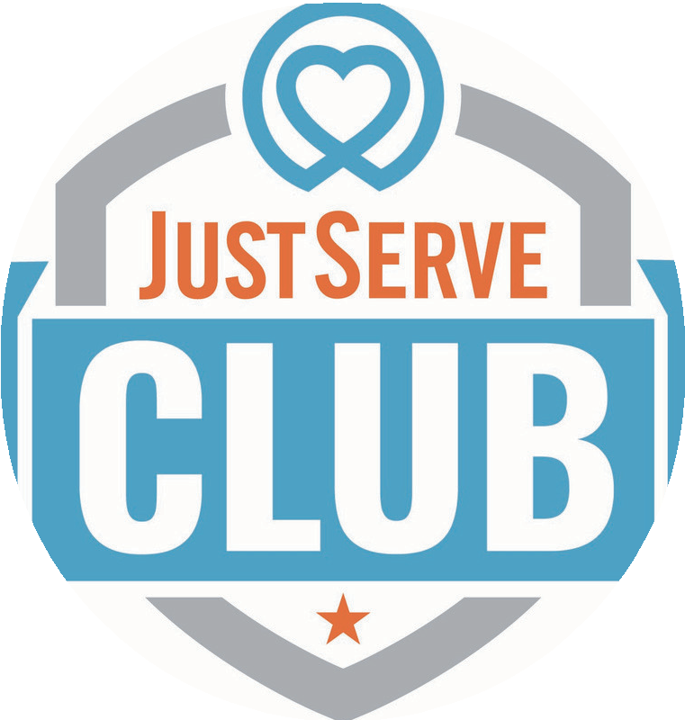
Club President

Club Advisor

