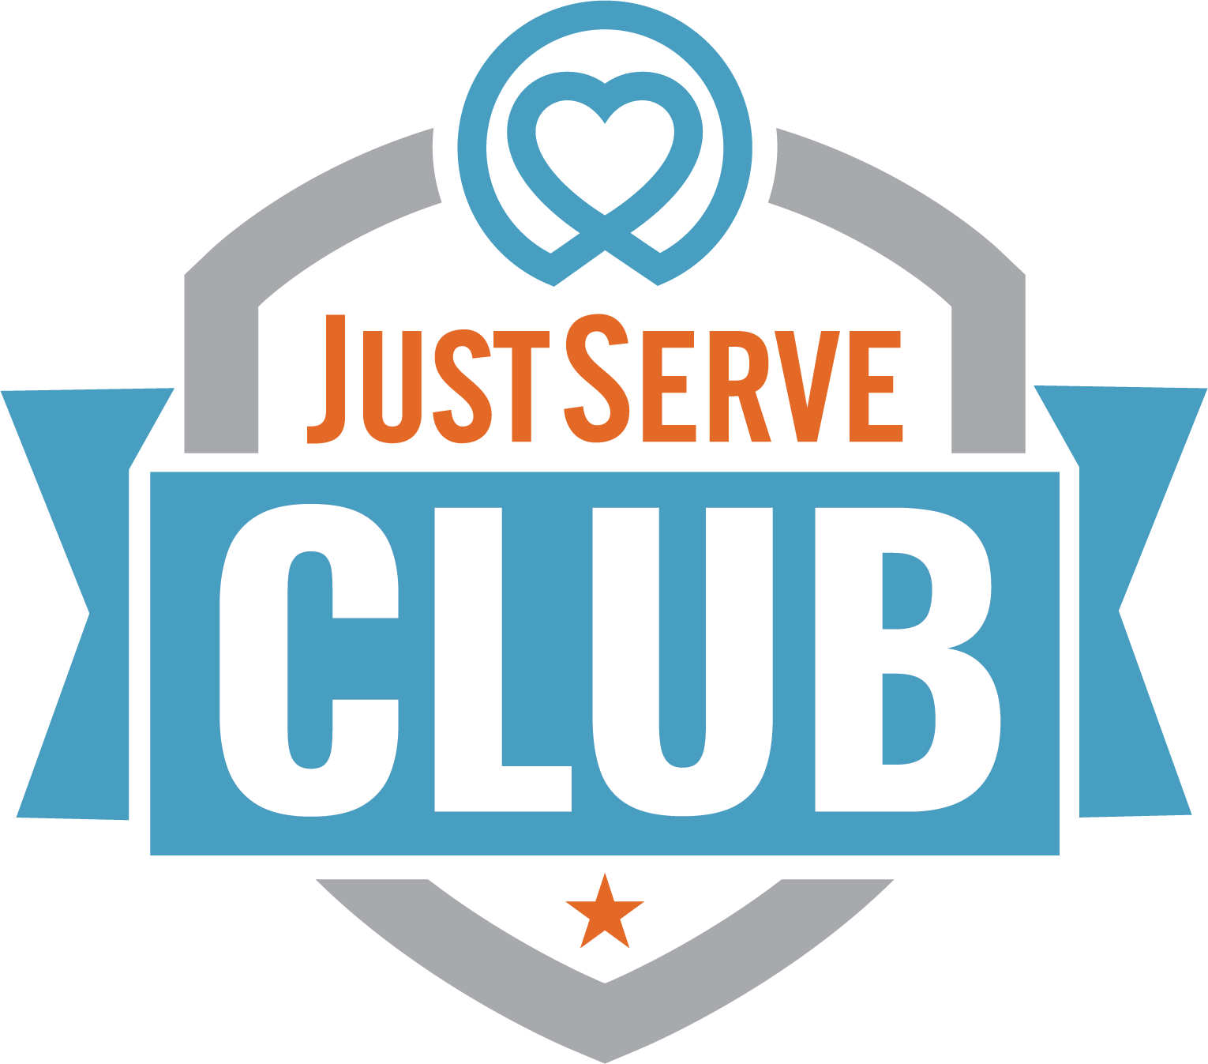
JUSTSERVE CLUB

REPRESENTING THE JUSTSERVE BRAND - RULES & GUIDELINES
JustServe is all about service. The student club is welcome to use the JustServe® trademark, name, and logo as long as a few simple guidelines are followed:
- Strictly follow the JustServe Style Guide whenever the trademark is used in any way.
- Don’t discriminate based on race, religion, gender, ethnicity, disability, sexual orientation, or any other protected status in the club or in the activities. Make the club a welcoming place that honors differences and encourages respect for everyone.
- No hazing.
- Service projects should be appropriate for the club members' ages, abilities, and experience. Avoid projects that could put anyone at risk or create uncomfortable situations, such as working one-on-one with someone they do not trust or handling tools or equipment they are not trained to handle. The goal is to help those in need and enhance the quality of life in the community.
- Get out and serve! Have fun. The JustServe website is a great place to find projects in the area. The best service opportunities are collaborative, working side by side with others in nonprofit, community, faith-based, and government organizations. Community service opportunities should enhance the quality of life in the community and assist the poor and those in need. JustServe projects should not have a political or other advocacy focus, be for-profit oriented, or directly involve volunteers in soliciting or handling money or other prohibited activities.
If the student club fails to follow these guidelines, permission is forfeited to use the JustServe® trademark. Adhering to these guidelines helps JustServe keep the trademark meaningful—a symbol of positive community service.
In addition to these guidelines, the student club should follow the rules of the school concerning student clubs. Research the policies at the school that apply to the student club, or ask the administration office or school counselor for help.
By using the JustServe® trademark and website, the club agrees to the Terms of Use and Privacy Policy posted on the website. By JustServe allowing the use of the trademark, this implies that JustServe endorses the club. JustServe does not provide insurance coverage or otherwise assume responsibility for club members or volunteers, even when the JustServe® trademark is used. The club is solely responsible for its own decisions, communications, meetings, and activities as a student club. JustServe is not liable for any club activities. The student club releases JustServe from any liability whatsoever.

