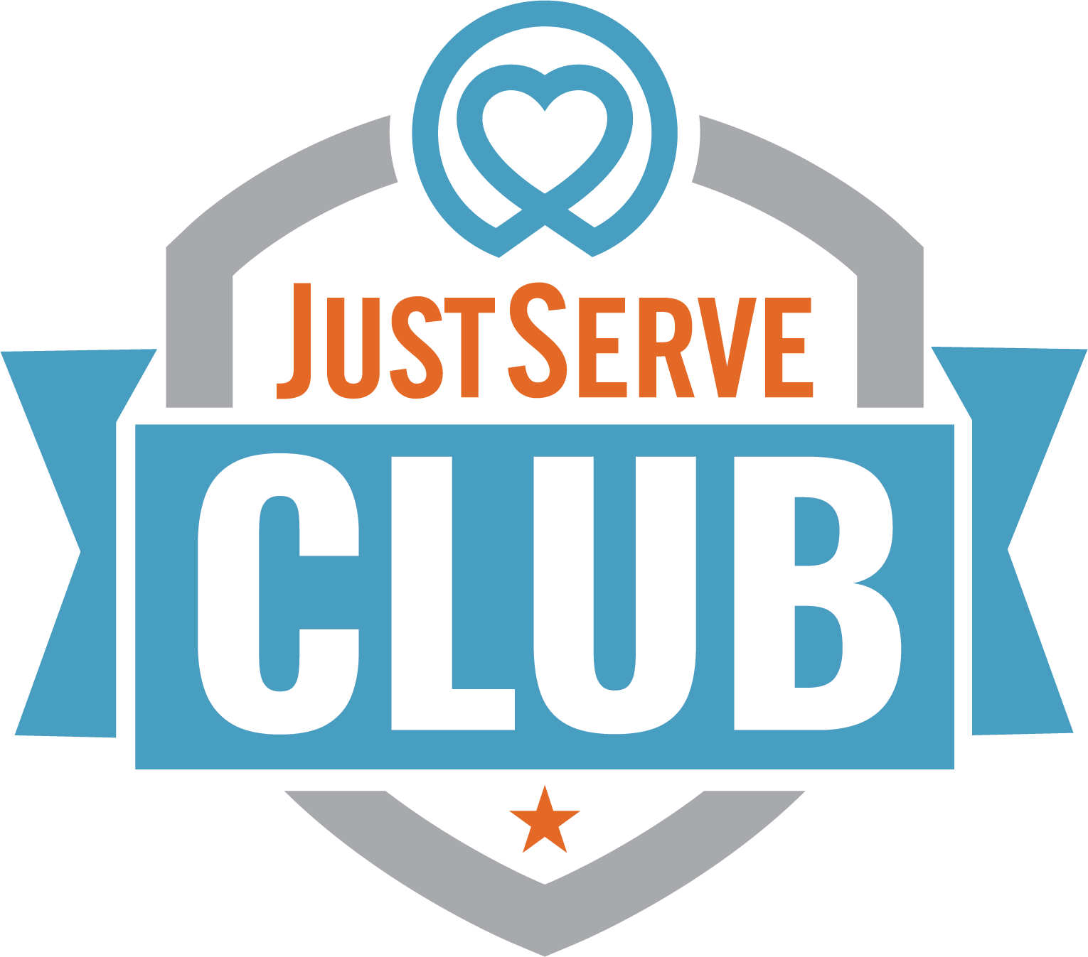
JustServe Clubs
Service Opportunities & Ideas
Listed are some service project ideas your JustServe Club can do together—either on campus or out in the community. We’ll continue to add to this list as new opportunities arise, and we hope you'll share your ideas as well.
Be sure to check JustServe.org regularly by ZIP code to find local needs. Don’t forget to look under “Remote Opportunities” for flexible projects. In some areas, a local JustServe Specialist may also reach out with service ideas—watch your email for updates. Before starting a project, check with a local nonprofit to make sure there is a real need for the service or donation you’re planning. Always confirm you're meeting a specific need.
Quick, Easy Service Project Ideas
Project Idea | Description
Birthday Message Videos | Record birthday messages for the Birthday Party Project, who deliver birthday kits to children in shelters.
Bus drivers' special gift, at your school | Write thank-you messages and deliver treats to school bus drivers.
Color A Smile | Color messages for seniors, troops, and veterans. https://colorasmile.org/
Decorate sack lunch bags for your local food shelter | Decorate lunch bags for a local food shelter that distributes sack lunches. Potentially check your local Salvation Army.
Dog or Cat Toys for Your Local Animal Hospital | Make cat toys or no-sew dog toys. Example: https://www.sylviasstitches.com/2018/05/no-sew-dog-toys-service-project.html
Handwritten Letter Campaign | Write letters of encouragement to women with breast cancer. [https://www.girlslovemail.com/
Heart attack work breakrooms - at your school, your local hospital, or first responders | Cut and deliver paper hearts with thank-you notes to healthcare workers, first responders, or teachers.
Holiday Decorations or Cards For An Assisted Living Home or a Dialysis Clinic | Create holiday cards or decorations for assisted living homes or dialysis clinics.
Kindness Rocks for your local park or a public preschool | Paint rocks with encouraging messages to place in parks or preschool areas.
Letters Against Isolation | Send cheerful handwritten letters to isolated seniors.  https://www.lettersagainstisolation.com/
Paracord Bracelets for Operation Gratitude or Write Letters to Those Who Serve | Write thank-you letters or make paracord bracelets. https://www.operationgratitude.com/
No Sew T-shirt BAG | Make no-sew t-shirt bags. Example tutorial: [YouTube](https://youtu.be/zgpaM3u2zng)
No-Sew Feet and Hand Warmers for the Elderly | Sew foot warmers using socks, rice, and ribbon. https://www.youtube.com/watch?v=d-QOZgP1wGE
Sidewalk Chalk Smiles | Write uplifting sidewalk chalk messages at school or around your neighborhood.
Walker Packets for individuals who use walkers | Make walker packets with fabric pockets. https://meandmyinklings.com/diy-pockets-for-walkers-as-service-project/
Washcloth Teddy Bears | Make teddy bears from new washcloths and donate them to nonprofits that provide hygiene kits for children. https://youtu.be/OwnMUY2ISjM?feature=shared

General Service Project Ideas
Project Idea | Description
Assisted Living Home | Bring flowers or play games with residents at assisted living homes.
Bake Sale | Host a bake sale to raise funds for a local nonprofit or food pantry.
Billion Graves | Photograph and document gravestones for genealogy. https://billiongraves.com/justserve
Birthday Boxes for Your Local Food Pantry | Assemble birthday boxes for food pantries with cakes, candles, and decorations.
Blankets | Make fleece or fabric blankets for foster children or other organizations that may need them.  My Very Own Blanket: https://www.myveryownblanket.org  Project Linus: http://www.projectlinus.org
Caroling for Cans | Carol in neighborhoods while collecting canned food donations.
Chemo Caps and Beanies | Sew or knit beanies and chemo caps for local hospitals or patients.
City Projects | Ask your city if there are upcoming service or planting projects to join.
City Trash Pick Up | Pick up trash at parks, trails, or school grounds.
Community Gardening or Trail Clearing | Assist with gardening or trail maintenance in your community.
Food Drive | Organize and promote a food drive at your school or church.
Group homes | Support your local group home by making treats or cards for the residents.
Hygiene Items for a Local Shelter | Collect hygiene items and assemble kits. Add kind messages inside.
Knots for Love | Crochet items for chemo patients or NICU babies. https://www.justserve.org/projects/4f2b930d-cb2c-4bde-be1d-af8d4faa6aff
Lasagna Love | Cook and deliver lasagnas to neighbors in need. [lasagnalove.org](https://lasagnalove.org/)
Mend Clothes | Mend gently used clothing for donation to shelters or safe houses.
Operation Gratitude Bandanas | Sew patriotic bandanas for Operation Gratitude care packages.
Organize a concert and perform musical pieces for seniors | Perform music at senior centers or retirement homes.
Pajama Drive for a local Foster Association | Host a drive and collect new pajamas and donate to a local foster care association
Red Cross Blood Drive | Promote school blood drives and encourage donations. https://www.redcrossblood.org
Ryan’s Case for Smiles | Sew pillowcases for children in hospitals. https://caseforsmiles.org
Scavenger Hunt for Cans | Host a scavenger hunt to collect high-need food items for pantries.
Senior Citizen history project | Interview seniors and help write their life stories.
Socks- collect mismatched or Gently Used Socks | Collect clean, mismatched or gently used socks. https://theoddsock.org/
Souls for Soles Shoe Drive | Host a shoe drive for kids in need. Everything included in how to run it here: https://www.justserve.org/projects/4cffc1ed-ba94-4e3c-8466-bc581ed6501b/collect-shoes-or-host-a-shoe-drive
Tech Table At Senior Home | Help seniors learn to use smartphones, tablets, and social media.
Thank Your Local Responders | Deliver thank-you gifts or notes to local police or fire stations.
The Magic Yarn Project | Make yarn wigs for kids with cancer. https://themagicyarnprojct.com/start-here/
Thrift Store Sorting | Sort and organize items at nonprofit thrift stores.
Toys For Furry Friends | Host a drive for pet toys and unopened food for animal shelters.
Toys For Tots (Holiday) | Run a school-wide toy drive to benefit Toys for Tots or firehouse programs.

Organizations Potentially in Your Area
Organization | Potential Ways to Help
American Red Cross | Volunteer at local blood drives or organize one at school. Install smoke alarms in their Sound the Alarm Events.
Boy Scouts / Girl Scouts | Collaborate on badge projects or community service days.
Catholic Relief Services | Support global needs.
Elks Lodges | Join local service projects or support veteran and youth initiatives.
Ronald McDonald House | Cook meals, clean, or create care kits for families of hospitalized children.
Rotary International | Partner on local service projects or attend youth leadership events.
Salvation Army | Sort donations, serve meals, or help with holiday drives.
UnitedWay.org | Connect with a wide variety of local volunteer opportunities.
YMCA | Assist with youth programs, classes, or community events.
Other Ways to Get Inspired
- Look at JustServe.org regularly for new projects in your area.
- Follow your local JustServe social media pages for updates and success stories.
- Ask your club members about causes they’re passionate about.
- Invite a nonprofit guest speaker to your meeting.
- Coordinate with local faith groups or service organizations.
- Join forces with other school clubs for a combined service event.

Other Ideas
- Follow the organizations you contact—sign up for their email newsletters and follow them on social media. Many post-volunteer needs and upcoming projects through these channels.
- Explore the Success Stories on JustServe.org for inspiration from other communities and ideas for meaningful service projects.
- Search the hashtag #JustServe on platforms like Instagram or Facebook to see real examples of what others are doing across the country.

