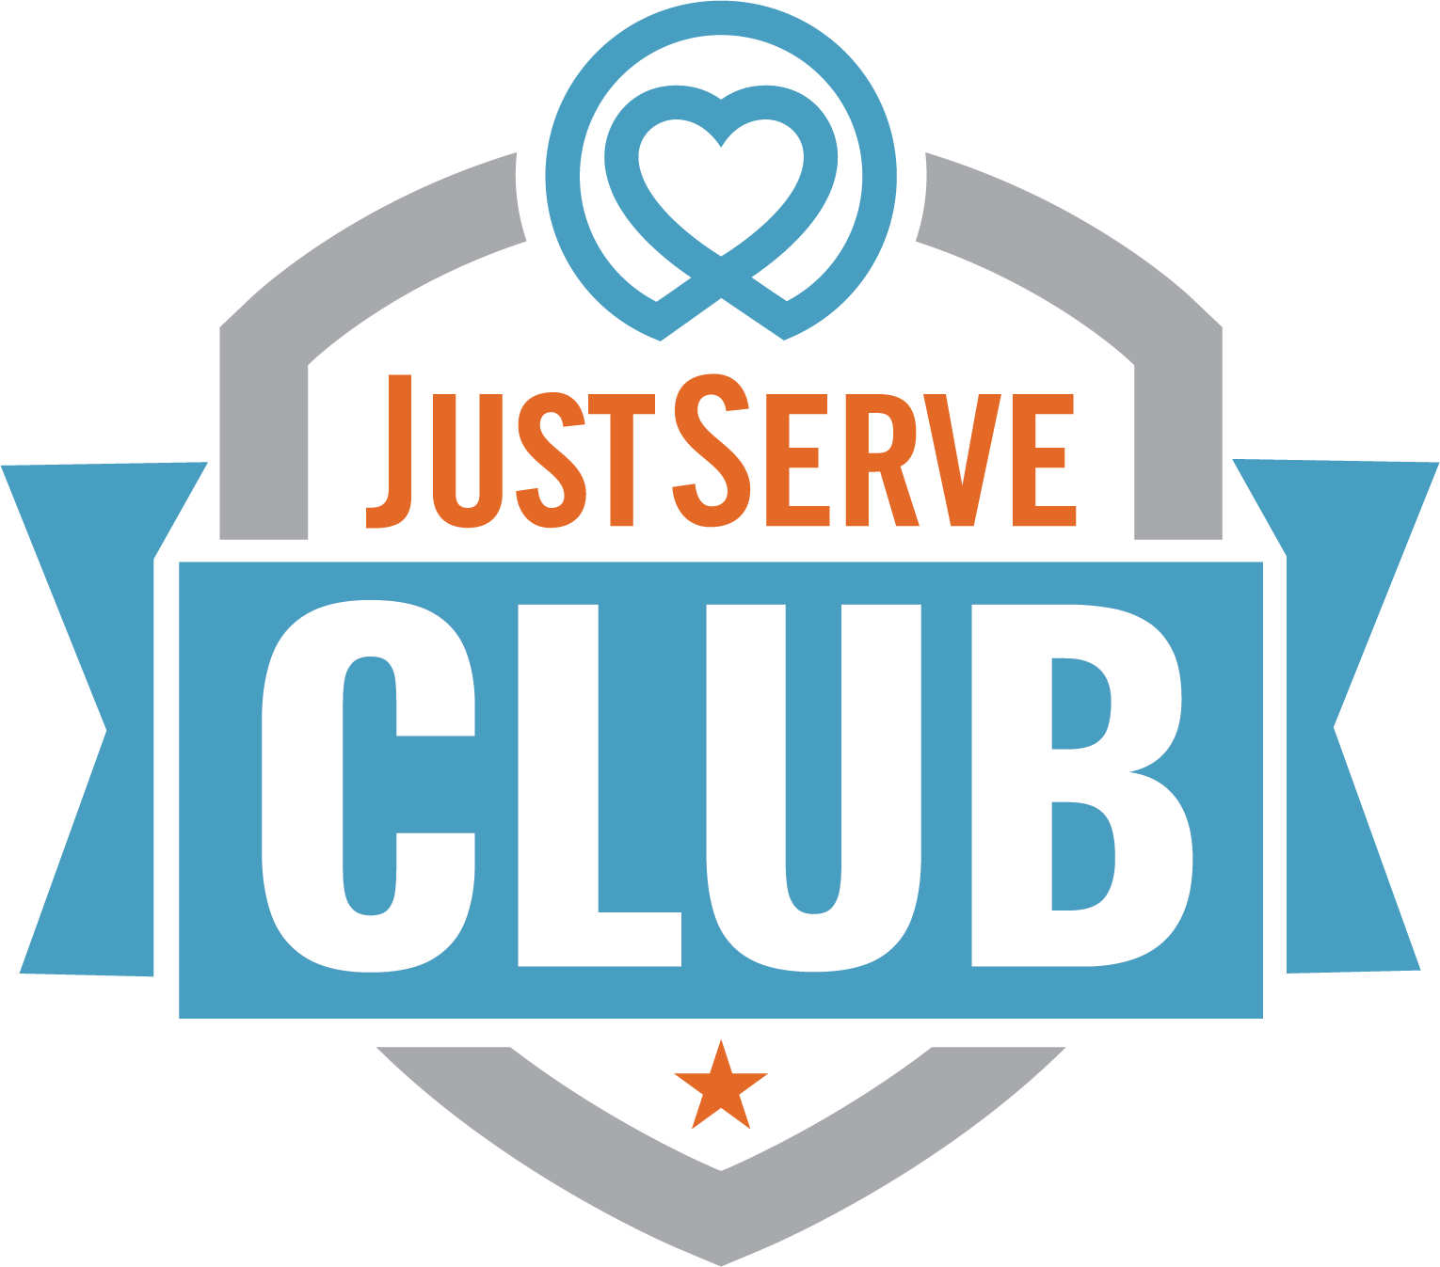

Join Our JustServe Club!
Looking for a club where you can make a difference, have fun, and meet awesome people? JustServe Club is all about helping others and making our community a better place together.

What We’re About:
We serve. We lift. We connect.
Through meaningful service projects, we build friendships and support each other while partnering with local organizations.
Why Join?
Make a real impact in your school and community.
Earn service hours for graduation, college apps, and resumes.
Get involved with cool projects and causes you care about.
Meet new friends who love to serve, too!

Want More Info?
Contact us at

