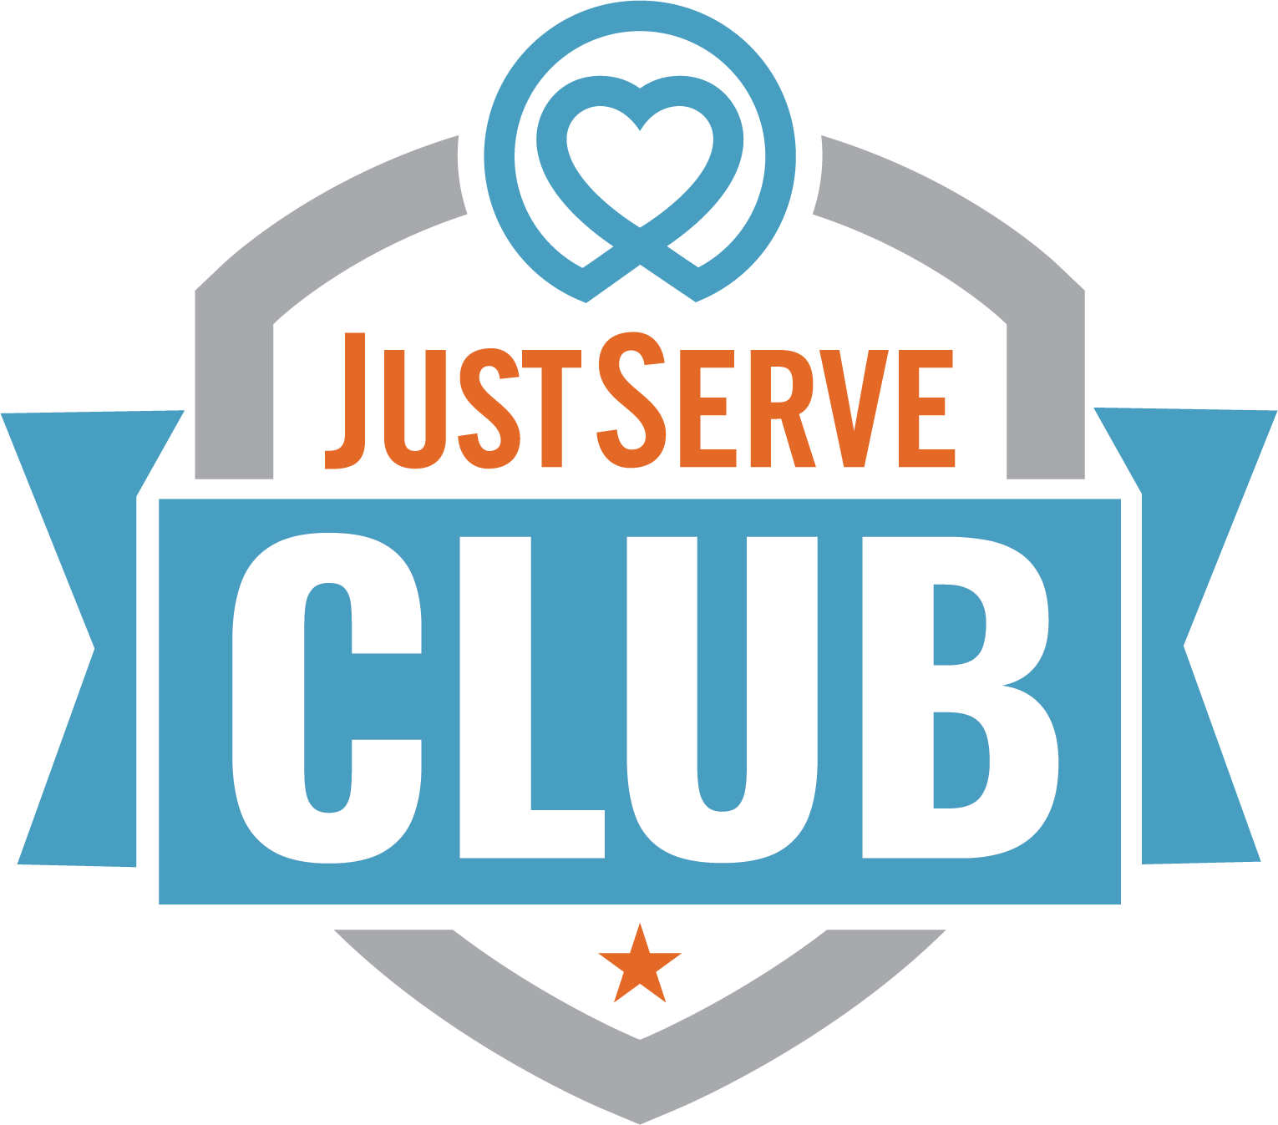
Join Our JustServe Club!  Looking for a club where you can make a difference, have fun, and meet awesome people? JustServe Club is all about helping others and making our community a better place—together.    What We’re About:  - We serve. We lift. We connect.  - Through meaningful service projects, we build friendships and support each other while partnering with local organizations.  Why Join?  - Make a real impact in your school and community.  - Earn service hours for graduation, college apps, and resumes.  - Get involved with cool projects and causes you care about.  - Meet new friends who love to serve, too!    Want more info?  Contact us at: |  | Join Our JustServe Club!  Looking for a club where you can make a difference, have fun, and meet awesome people? JustServe Club is all about helping others and making our community a better place—together.  What We’re About:  - We serve. We lift. We connect.  - Through meaningful service projects, we build friendships and support each other while partnering with local organizations.  Why Join?  - Make a real impact in your school and community.  - Earn service hours for graduation, college apps, and resumes.  - Get involved with cool projects and causes you care about.  - Meet new friends who love to serve, too!  Want more info?  Contact us at:
Join Our JustServe Club!  Looking for a club where you can make a difference, have fun, and meet awesome people? JustServe Club is all about helping others and making our community a better place—together.  What We’re About:  - We serve. We lift. We connect.  - Through meaningful service projects, we build friendships and support each other while partnering with local organizations.  Why Join?  - Make a real impact in your school and community  - Earn service hours for graduation, college apps, and resumes  - Get involved with cool projects and causes you care about  - Meet new friends who love to serve, too!  Want more info?  Contact us at: |  | Join Our JustServe Club!  Looking for a club where you can make a difference, have fun, and meet awesome people? JustServe Club is all about helping others and making our community a better place—together.  What We’re About:  - We serve. We lift. We connect.  - Through meaningful service projects, we build friendships and support each other while partnering with local organizations.  Why Join?  - Make a real impact in your school and community  - Earn service hours for graduation, college apps, and resumes  - Get involved with cool projects and causes you care about  - Meet new friends who love to serve, too!  Want more info?  Contact us at:

